**ANALYSIS AND DESIGN**

The requirements raised by the client for this project is to create a booking application for their hair salon. As per the client, the app should have 3 different user types with 3 different UI, with the user types being Admin, Student/Hairdresser and User.

As the first step of the development process, I created an initial design for the client, containing all the requirements raised by them, that way I can get feedback and build my app around the client feedback. The hair salon app will have 3 different UI for the 3 different user types. When a user first opens the app, they will be navigated to the login/registration page, where the new users can register to the app by pressing the ‘Register’ button, which takes them to the registration page, which requires the user to input their Username, Email address, User type, Password and Password confirmation, after inputting these credentials and choosing the preferred user type, the users will be taken to their respected home page. As for the login page, the design is similar to the registration page where the user will be asked to input their Email address and Password.

After log/registration, the user will be taken to the main home page

The resource gathering for this project was made through an interview with the client as well as the primary users of this app, which would include admins who would managing the business, students/hairdresser who will be utilizing this app to book in for shits and the users who will be using the app to book their appointments. From this we were able to gather information such as important design structures and other necessities, we were also shown designs and features of another app which closely resembles how the client wants this application to look like. This input allowed us to create a simple outline for the app, including its design structure to present to the client which allowed us to get feedback to ensure that the project was on the right track.

From this feedback gathering phase, we were able to understand that the main client required the app to have 3 different UI for the 3 different user types, which will vary in accessible information, meaning that for user type 1 (Customer), they can only access information ranging from booking appointments, cancelling appointments, leaving feedback, making payments etc., whereas for user type 2 (Student/Hairdresser), they can access information such as, choosing and accepting time slots, viewing customer feedback approved by the admin, scheduling page where they can apply for overtime and holidays, and finally for user type 3 (Administrator), they can access information including, managing and allocating time slots for hairdressers, managing the payment system, reviewing user feedback and approving them for the students to view, accessing student and user messages. We were also able to gather information regarding the design of the app, which they required to be similar to the college logo design, which is simple white and blue. From the interview done with students and users, many required the app to be simple with legible information and easy navigation, this feedback was taken into consideration when designing each screen, where we have simple buttons with icons representing its functionality, limited animations, readable font size and style with simple colors to ensure that the information is readable for users, this design pattern is followed throughout all the pages to ensure that it's easy for the users to navigate through the app. There were also limited to none pictures and videos to limit the loading times for the app and ensure performance of highest quality.

**SWOT Table:**

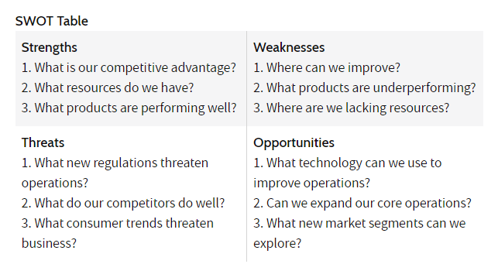  
**Strengths**

* The new system is designed to incorporate the wants and needs of this specific Hair salon, where the official iSalon app is designed for all the college salons in general. By doing this, we can produce a website which provides the clients with all the necessary tools which they require for managing the salon, such as the allowing the hairdressers to provide their availability based on their college schedule, which makes it easier for the administrators and clients to manage and make bookings respectively.
* In the new system, the User Interface is made simpler, where all the necessary information is provided upfront in an understandable manner. Since there would be customers who lack computer expertise, designing the UI to be simple would create a system that is user friendly and hence improve the number of recurrent users and new users. This would also benefit the administrators who are managing the system, such as managing the bookings, schedule, payments etc.
* In terms of resources required for the development of the application, the primary requirement would be a server and a backup server to contain all the important data, hence it would be cost effective. Since the system is designed for this specific salon, the amount of data would be less compared to iSalon. The cost required for the project would be comparatively low considering the number of users. The cost would only be gradually increased based on the increasing number of users in the future, when we would have to upgrade the hardware.
* The project would be carried out using Agile methodology, this means that client feedback would be a major part of the development process, allowing us to create a system that fits their specific needs. The specification can be customized during every phase of development, meaning that if there were anything new to be added to the system, that can be done without having to change any of the previous data.

**Weakness**

* The budget for the project is limited, compared to the overall budget for the development of the iSalon app. Due to this reason, the quality of the products would have to be compromised, such as the size of the server and the cost for maintenance of the system after its deployment.
* Due to the limited number of users developing the application, developing and deploying timely updates would be limited. The number of developers would also affect the time period required for the development of the project, considering several tests should be conducted before deploying it to the general public. ISalon has a larger development team, who are focused on maintaining the app after its deployment.
* Compared to our system, iSalon has a more polished application/website, where it has been in development for months and was deployed after conducting several tests to ensure that it is fully ready for the public.

**Threats**

* Since the budget of this project is comparatively low, the quality and amount of product would have to be compromised.
* ISalon has a wider audience compared to this specific hair salon, hence the number of customers would be limited.
* Having a limited amount of equipment such as servers would affect the safety of data stored by the salon, data including the sensitive information of their clients such as their name, contact information etc.

**Opportunity**

* Compared to iSalon, this project focuses on a single client, whose requirements we need to follow. Hence the application would be tailored to the client's needs
* With the implementation of feedback system in the new app, we could have the opportunity to provide the hairdressers/students with where they must improve.
* The new system has a more defined booking system

**Trello Board:**

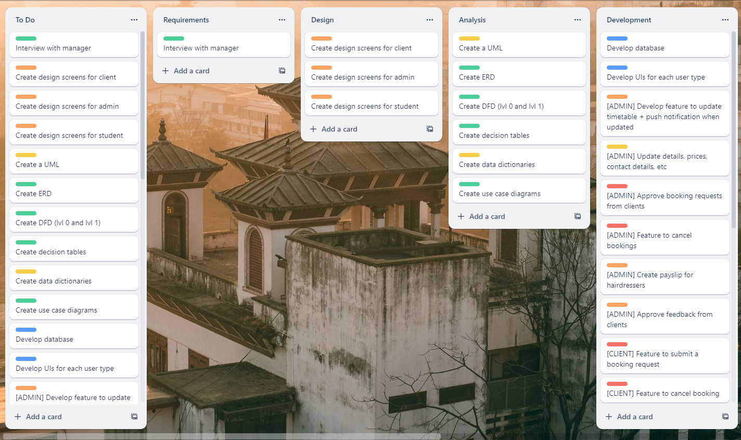  
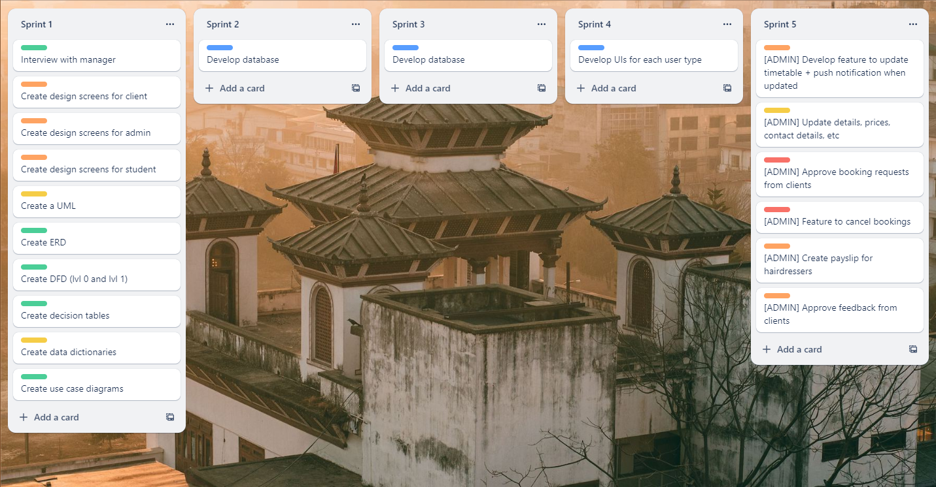  
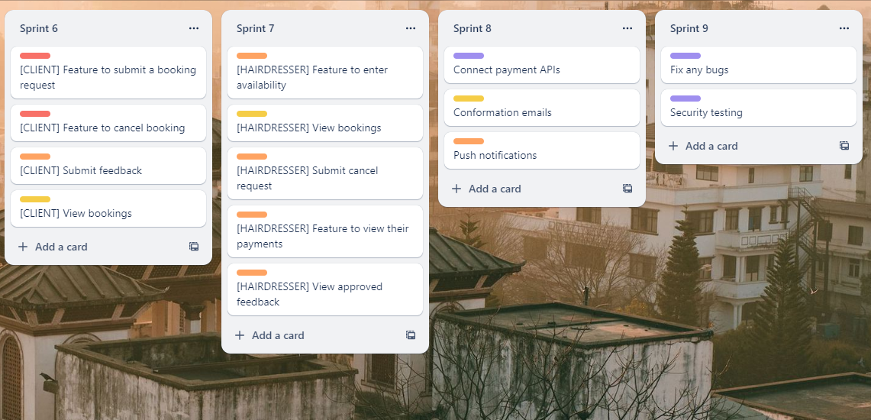  
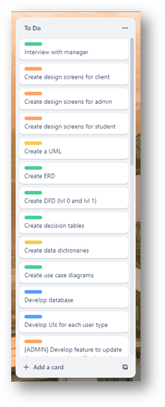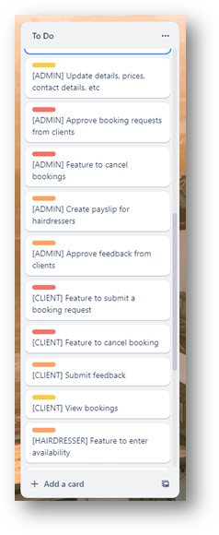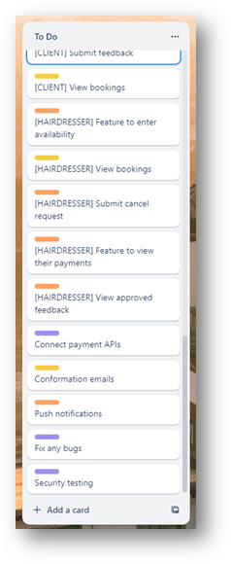

A set of tasks which need to be done during the progression of the project are listed out. These tasks are then categorized into several sub sections, which includes what needs to be done during the Requirement Gathering phase, Design phase, Analysis phase etc.

As a group, the duration of time which would be required to finish each task are agreed upon during the poker planning phase. In this phase, the different time scales are defined through different methods, one of which would be t-shirt sizes;

**The size Extra Extra Small would represent – Few hours**

**The size Extra Small would represent – A Day**

**The size Small would represent – A few days**

**The size Medium would represent – A week**

**The size Large would represent – Couple of weeks**

**The size Extra Large would represent – A month**

**The size Extra Extra Large would represent – Over a month**

The first task in the requirement gathering phase is where we gather the essential information from the Hair Salon manager through an interview, that is required to be in the application. In this instance, the necessary information collected by us includes:

* Preferred payment method
* Database system
* Rating and Feedback system
* Booking system
* Cost of building

This task is labelled as **XXS**, meaning that this would be done within a few hours, since this project utilises Agile methodology, more feedback can be gathered during the development phase of the project.

Next is the Design phase, where the UI design for the client, admin and the student pages are discussed. The screen design for each of the pages would be different for each of the pages, meaning that the UI design for the admin would differ from the UI design for the clients, which would be more simplified.

The Analysis phase would include creating several diagrams including a UML diagram, ERD diagram, DFD (Level 1 and Level 2), creating Decision Tables, creating Data Dictionaries and User Case Diagrams.

Creating the UML diagram is labelled as **XS**, meaning that it would take a day to complete it, creating the ERD diagram is labelled as **XXS**, meaning that it would only take a couple of hours to complete this task, creating the DFD (Level 1 and Level 2) diagram is also labelled as **XXS**, meaning that it would only take a couple of hours to complete.

**P5**

The following are the screenshots of the code for the login/registration page:

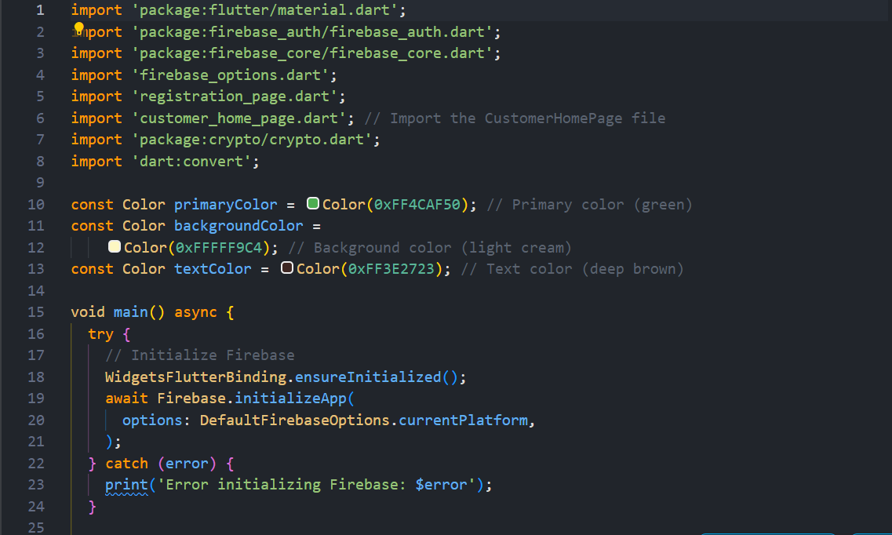

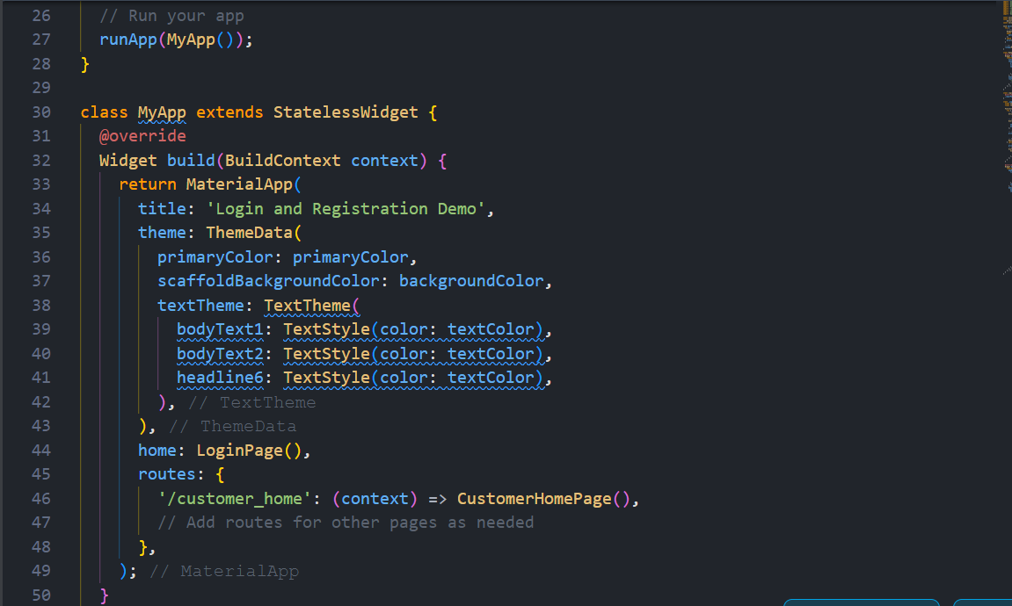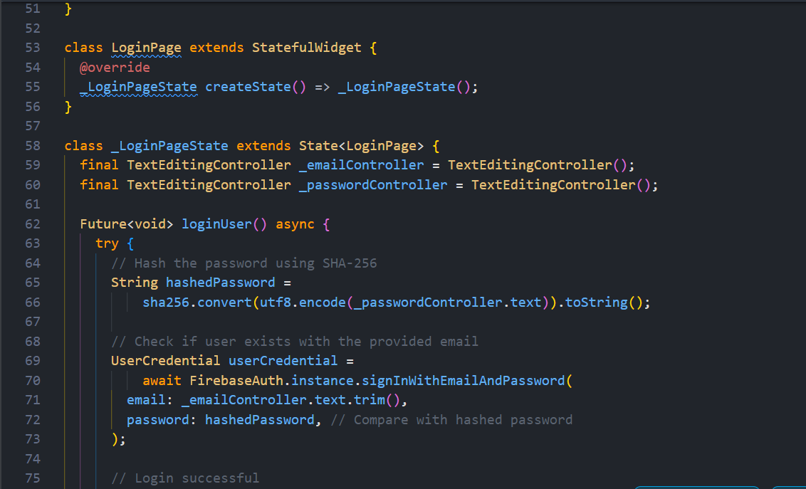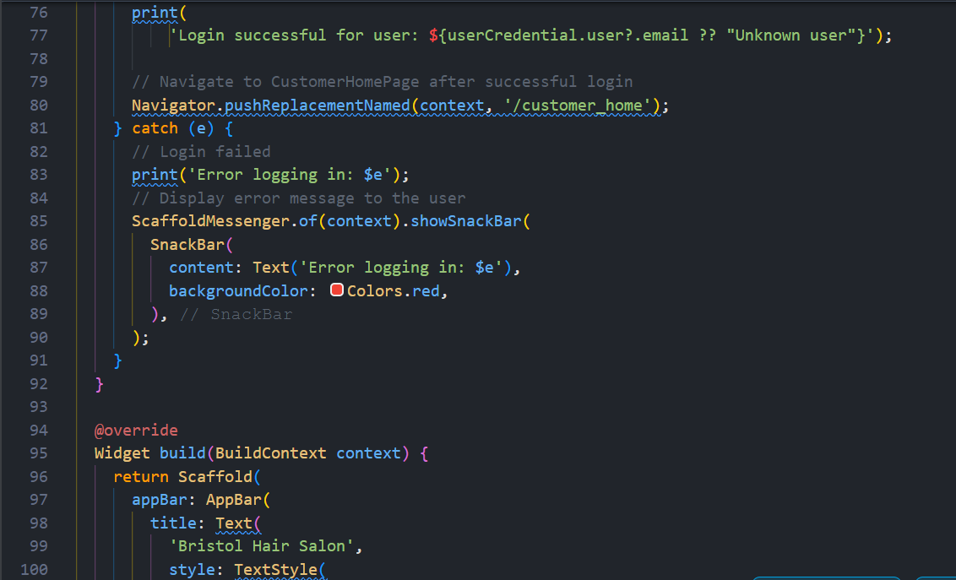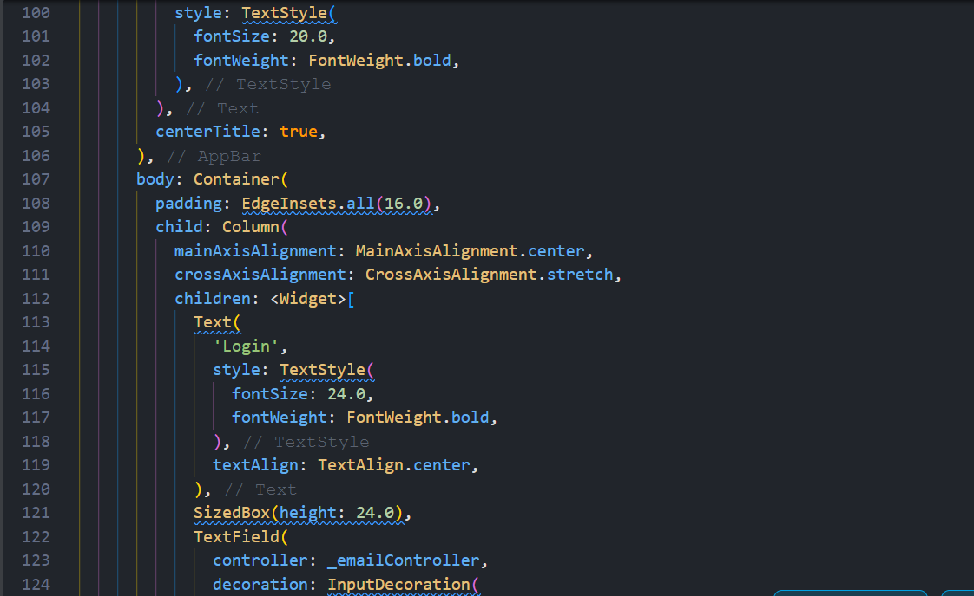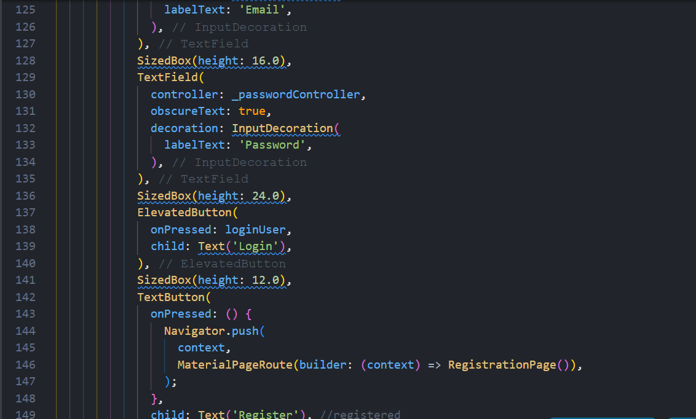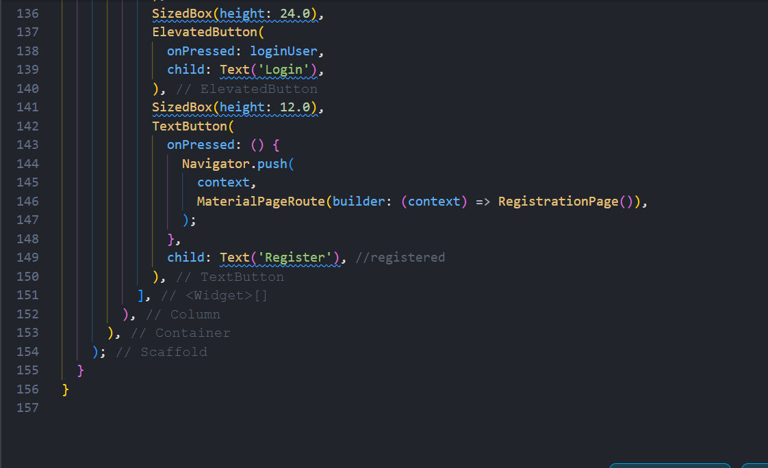

Agile methodology was adopted for this project, this decision was taken due to the several benefits it provides due to the structure. Some of the benefits includes better risk management, faster fixes and solutions, increased room for pivot and experimentation, more responsive to customer feedback etc.

With the project, we have to design and create a product similar to one that already exist, but it requires us to design the product to fit their specific criteria, this would require an extensive client feedback system which is one of the pivotal factors of Agile methodology. This methodology would allow us to collect client feedback during all the different phases of the project, including the primary/initiation phase, planning phase and the execution phase, this also allows us to input the new ideas without having to alter any of the previous data.

Several diagrams are utilised to create and understand the structure of the project, tools such as DFD, ERD and UML diagrams were utilised. The DFD diagram allowed us to map out the flow of an actual Hair Saloon app, with this we were able to plan and design each of the stages for the production of the application, this meant we were able to have a clear understanding on how to map out the project.

Another tool we were able to utilise during this project was the User Case Diagram, this allowed us to create a hierarchy system, in which only certain users can access certain information, e.g. as shown below, only the certain users to access certain features of the app, such as only the admin having the access to changing the prices, accessing the user feedback, updating the schedule etc. This hierarchy system allows to maintain a level of security in the system, due to only certain users having the authorisation to access to important information such as the payment system and scheduling system.

Trello board was another important tool that aided with the management of the project, with the Trello board we were able to map out what each phase of the project were and when each of these tasks needed to be finished. We were also able to

During the interview with the manager, it was mentioned that they require a feedback system where users can input their feedback anonymously or with their details, but the feedback would only be able to view by the hairdresser after being filtered by the administrator, the administrator can remove or delete messages that are irrelevant or malicious comments. The hierarchy system which was created using the help of these diagrams allowed us to create this feedback system as requested by the client.

The UML and ERD diagrams, we were able to make simplistic representations of the system we are creating, which we were able to show the client, from which they were able to have a grasp of the new system being created and was able to give us their feedback on what to be added and to be improved. This was one of the instances where the chosen tools integrated with the chosen methodology.

**UML Diagram**

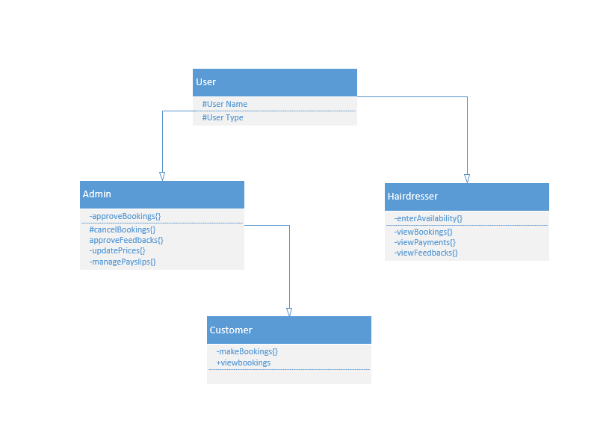  
**D2**

With the development of the new system, several new features were added which were not present in the previous application, the previous system can only be considered as a pre-alpha version since it lacks several factors that should consist in a booking app, the new system improves the overall user experience and usability of the application with the addition of several new features.

Some of the new features include scheduling system, this allows the hairdresser to add and remove their availability, this new feature would empower the hairdresser to manage their schedules effectively. This could also result in an improved user experience, since both the users and the hairdressers can use the application effectively. The scheduling system also reduces the time it takes to email or SMS message the customers regarding the unavailability of certain hairdressers, instead the customers can directly see the availability of their hairdressers and book appointments accordingly. The customer would also be sent a confirmation email/SMS after they booked their appointments, along with messages if a hairdresser is unavailable after an appointment has been made, this new system reduces the number of communication errors and is also effective when it comes to managing the time of the customers and the hairdressers.

Another improvement would be the implementation of a validation system to ensure that the female customers have undergone skin test before certain procedures, this was one of the requirements raised by the client during the requirement gathering phase. This validation system would save time, where the customer can confirm or deny if they have undergone skin testing before undergoing certain procedures, if they haven’t, the hairdresser can advise them to do so before coming in for their appointment, this would save both the hairdresser’s and the customer's time.

There are certain negatives that needs to be considered with the implementation of all these new features, one of which would be updating the application regularly. The app needs to be updated regularly to be compatible with the newer operating systems of the phones, the different OS of the phones and other devices needs to be considered, such as compatibility with iPhone OS, Android and if the app is accessible properly on windows. All these requirements would mean that different versions would need to be developed, which would be costly and time consuming, especially considering the testing of each of the different versions and fixing potential bugs, which would take longer due to how understaffed the project is.

The availability of resources such as devices to run tests is also low compared to the number of tests that need to be ran, this would mean that the project would take longer to complete, and updates would not be as frequent as other applications.

Another negative would be the number of malicious comments that would be present in the feedback section, which needs to be filtered by the admin, this is another time-consuming factor.

Although the implementation of the new scheduling system and feedback systems comes with certain drawbacks and update issues, the pros it brings outweigh the cons, such as the feature for hairdressers to provide their availability benefits the customer when booking an appointment, it creates an efficient system where there would be no confusion between the customer and the hairdresser.

The feedback system, although it requires the admin to filter them out can provide positive reinforcement for the hairdresser, where a positive comment can empower them to be more creative and confident, which thereby improves the customer satisfaction in the future.

These positive feedback can also be added to the profile of each of the hairdressers, so that the customer would have an idea of the different capabilities of the hairdresser and choose accordingly.

**D3**

The project requirements were met proficiently, with all the information gathered during the requirements gathering phase present in the final application. This was made possible due to the adoption of the Agile methodology, which allowed for the client feedback during several stage of the project.

As discussed, the app contains a scheduling system, which allows the hairdressers to provide their availability to their superiors and the customers, the administrators can also manage the scheduling system according to their timetable.

The technological constraints, compared to the already existing system would be the budget, number of resources and the maintenance of the application after the launch. For the new system, there were several new features that has been introduced, features such as a refined scheduling system, payment system, feedback system etc. All of these also needed to be designed to be compatible with different operating systems, such as Android, IOS, Windows etc. Another technical constraint includes the testing after the development of the application, all of the new features needed to be tested to ensure that there are no faults or bugs, due to the reduced number of resources such as testing equipment, each of the features along with the different versions of the application would need to be tested on the equipment that we have, which would be time consuming and would lead to a possibility where the certain bugs has been missed by the testing team.

Publishing timely updates would also be an issue we would face due to the reduced number of resources, which would lead to an outdated application. The updates would also need to be tested, resulting in missed deadlines.

With the help of SCRUM board and sprint sessions, we were able to have a discussion on which of the features that needed to be developed first,

The collective decision when choosing which feature to develop was purely logical, having created a database first allowed us to have a foundation of the app, then the visual User Interface for each of the user list, such as a UI for the customer, admin and the hairdresser was created.

When working as a team, the only issue we encountered was when deciding the time taken for each of the tasks, but this was resolved with the adoption of poker planning. With poker planning each of the team members wrote their own predictions and then were revealed in unison, each of the members were given opportunities to explain their decisions, with this we were able to come to an understanding on what to label each task.

But in the future, in order to develop a working app, which would be used by numerous users and would require us to provide timely updates, the resources required would need to be a lot more along with the budget of the project. The limited experience with creating apps meant us having to do research and a primary option was to rely on YouTube tutorials